**Data Visualization using Dataset**

Jyothi vasamsetty ([jvasamse@kent.edu](mailto:jvasamse@kent.edu))

Sithamshu teegala ([steegal1@kent.edu](mailto:steegal1@kent.edu))

Samhitha yeluri (syeluri@kent.edu)

**Project proposal:**

The goal of the project is for you to develop an interactive, Web-based visualization showcasing a real-world dataset. The project will aim to provide an interactive overview of the data set and other variable averages level. In addition to the value of the average column, the dashboard will allow exploration of features correlation and presence between the categorical dimensions, and show the top principal components with the highest attribute loadings. I also hope to illustrate it on the individual level; a section of the dashboard will show the individual profile.

**Data set description:**

The data set is obtained from <https://dcc.mit.edu/data> where The data is released in January 2022 and open to anyone online who was interested in taking it.  As we continue to collect data, this will be updated with additional folders reflecting the date of release. The easiest way to download the data is through AWS S3 command line tools. Instructions for installation of AWS CLI tools can be found here: [https://docs.aws.amazon.com/cli/latest/userguide/getting-started-install...](https://docs.aws.amazon.com/cli/latest/userguide/getting-started-install.html)

**System architecture:**

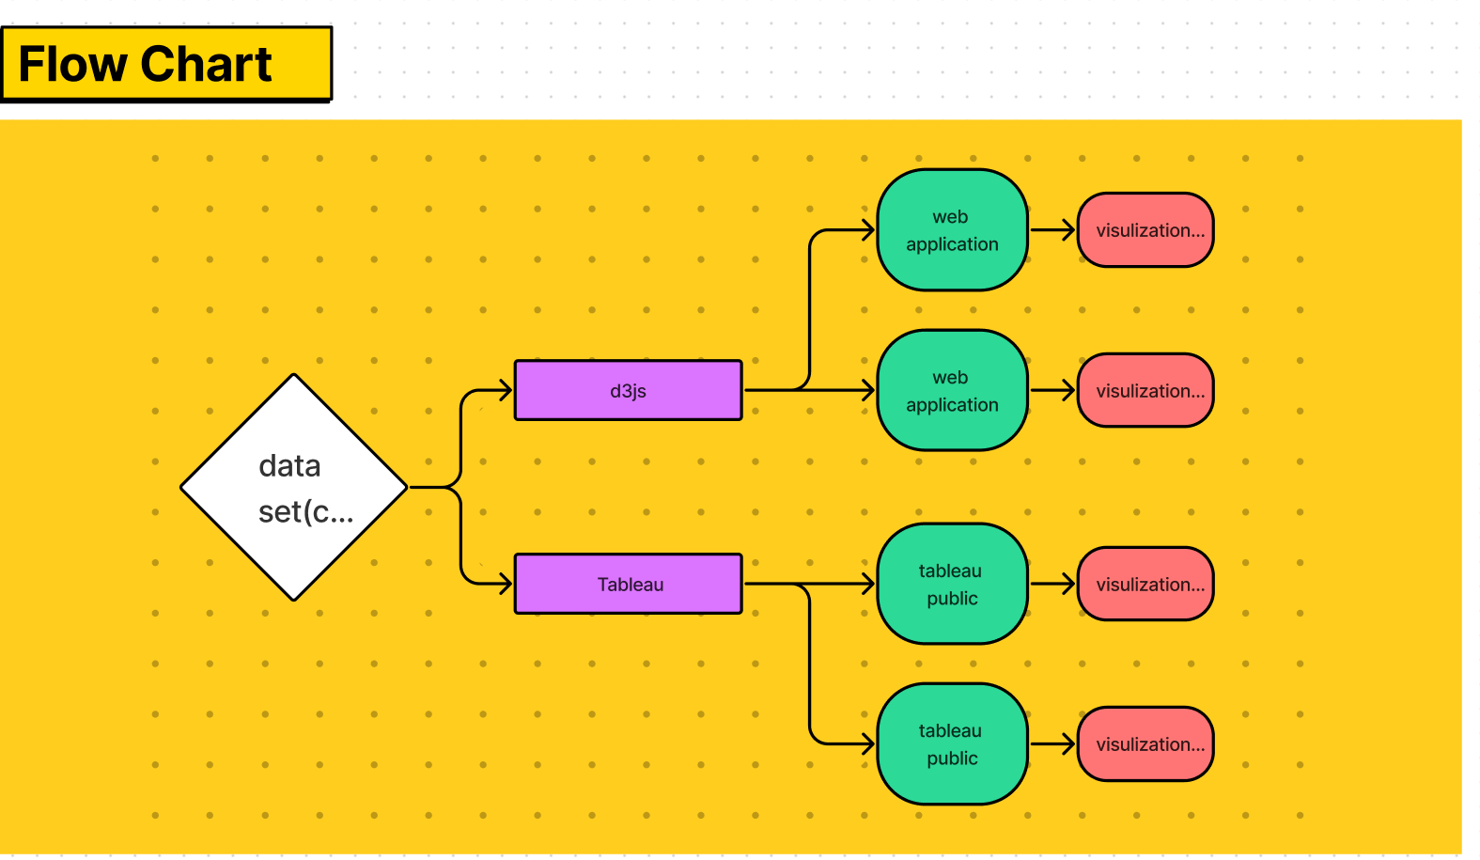

**Frameworks and tools going to be used:**

D3JS

Tableau

Visual studio code

we are using the d3js and tableau frameworks where D3.js is a JavaScript library for manipulating documents based on data. D3 helps you bring data to life using HTML, SVG, and CSS. D3’s emphasis on web standards gives you the full capabilities of modern browsers without tying yourself to a proprietary framework, combining powerful visualization components and a data-driven approach to DOM manipulation. D3 is not a monolithic framework that seeks to provide every conceivable feature. Instead, D3 solves the crux of the problem: efficient manipulation of documents based on data. This avoids proprietary representation and affords extraordinary flexibility, exposing the full capabilities of web standards such as HTML, SVG, and CSS. With minimal overhead, D3 is extremely fast, supporting large datasets and dynamic behaviors for interaction and animation. D3’s functional style allows code reuse through a diverse collection of official and community-developed modules.

Where tableau Combining people, process, and technology, the Tableau Governance Framework creates accountability and enables access to secure and trusted data for all skill levels in your organization to balance between agility and control of data.

**Features to be implemented:**

in this data visualization, we are implementing the multi-purpose dashboard in a tableau and animation charts by using d3js eg: pie charts, scatterplots, etc.